THE UNIVERSITY OF AZAD JAMMU & KASHMIR, MUZAFFARABAD


COURSE TITLE | COMPUTER NETWORKS
COURSE CODE | CS-2203
TITLE | LAB 1
STUDENT NAME | HASEEB SHEIKH
STUDENT ROLL NUMBER | 2024-SE-31
INSTRUCTOR NAME | ENGR. DR. ASMA JAVED
SUBMISSION DATE | MARCH 01, 2026

DEPARTMENT OF SOFTWARE ENGINEERING
Computer Networking
Lab 1
1. Objective
The primary objective of this lab is to successfully install Cisco Packet Tracer 9.0.0 (64-bit) on a Windows operating system and verify its operational status by launching the application interface.
2. Prerequisites
- Operating System: Windows (64-bit architecture)
- Software Executable: Cisco Packet Tracer 9.0.0 Setup Wizard
- Storage Requirement: Minimum of 715.0 MB of free disk space
3. Introduction
Cisco Packet Tracer is a comprehensive network simulation tool that allows users to create network topologies and imitate modern computer networks. The software is utilized for practicing network configuration, troubleshooting, and understanding complex networking concepts in a virtual environment.
4. Step-by-Step Installation Procedure
Step 1: License Agreement Run the setup executable to initialize the setup wizard. The installation begins with the End User License Agreement (EULA). Read the terms, select the radio button corresponding to "I accept the agreement", and click Next to proceed.

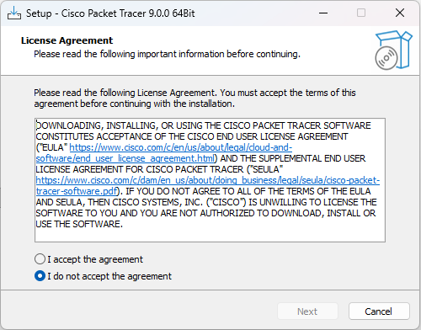

Step 2: Select Destination Location The setup prompts for an installation directory. The default path is set to C:\Program Files\Cisco Packet Tracer 9.0.0. Verify that the system has at least 715.0 MB of available free space, as indicated at the bottom of the window. Leave it as default or click Browse to choose a different location, then click Next.
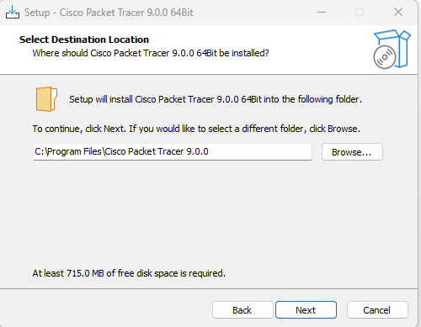

Step 3: Select Additional Tasks The wizard provides options to configure desktop and quick launch shortcuts. Check the box for "Create a desktop shortcut" for easier access to the application later, then click Next.
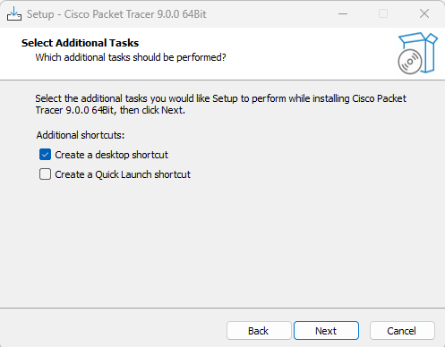

Step 4: Ready to Install A summary screen displays all the configured installation settings, including the destination location, Start Menu folder, and selected shortcuts. Review these details to ensure accuracy, and click Install to begin the writing process.
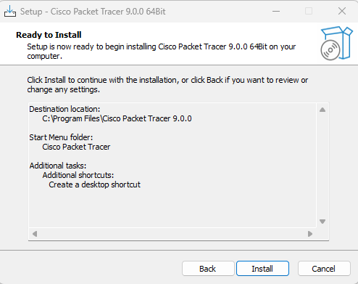

Step 5: Installation in Progress The setup wizard will begin extracting and copying files to the local drive. A green progress bar indicates the installation status. Wait for this process to complete entirely without interrupting it.
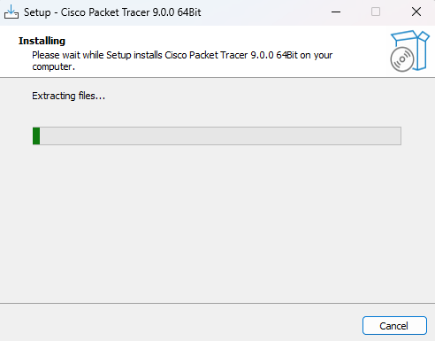

Step 6: Completing the Setup Wizard Once the file extraction and installation are done, a final confirmation screen appears. To immediately verify the installation, ensure the "Launch Cisco Packet Tracer" checkbox is selected, and click Finish.
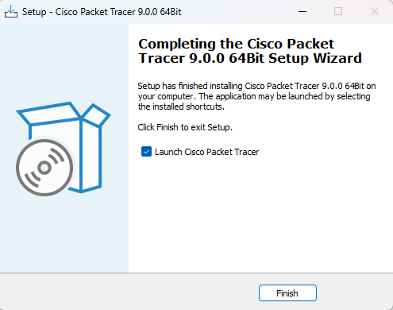
Step 7: Verification and Launch The Cisco Packet Tracer application will execute and open to its default workspace. The presence of the logical/physical workspace tabs and the network component library at the bottom confirms that the software has been installed successfully and is ready for use.
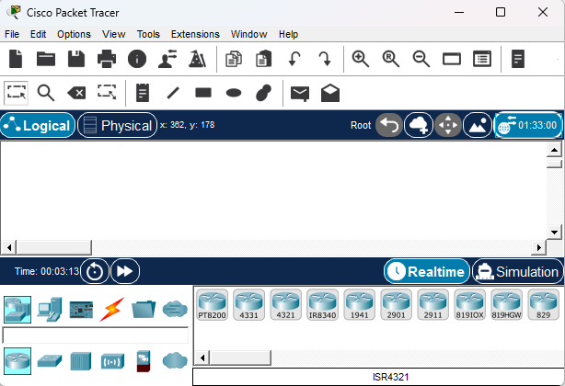
5. Conclusion
The installation of Cisco Packet Tracer 9.0.0 64-bit was completed successfully with no errors encountered during the setup wizard execution. The application launched correctly, demonstrating that the environment is fully prepared for subsequent network simulation tasks.

